1. The Excel interface contains several elements that make it easy to create, edit, and manage spreadsheets. Here are the main components of the Excel interface and how to use them:

* Ribbon: The ribbon is a series of tabs located at the top of the Excel window. Each tab contains groups of commands that are related to a specific function. For example, the "Home" tab contains commands for formatting text, applying styles, and inserting rows and columns.
* Quick Access Toolbar: The Quick Access Toolbar is a customizable toolbar that contains shortcuts to frequently used commands. It is located above the ribbon on the left side of the Excel window. You can add or remove commands from this toolbar according to your preferences.
* Formula Bar: The formula bar is located above the worksheet area and displays the contents of the current cell. You can use it to enter or edit formulas, functions, or data.
* Worksheets: A workbook in Excel can contain multiple worksheets. Each worksheet is a separate tab at the bottom of the Excel window. You can use the worksheet tabs to navigate between the different sheets, and you can add or delete sheets as needed.
* Cells: The cells are the individual rectangular boxes that make up the worksheet. You can enter data, formulas, or functions into cells, and you can format them to adjust the appearance of the data.
* Columns and Rows: Columns are vertical groups of cells that are identified by letters (A, B, C, etc.), while rows are horizontal groups of cells that are identified by numbers (1, 2, 3, etc.). You can insert or delete columns and rows to adjust the layout of your worksheet.
* Status Bar: The status bar is located at the bottom of the Excel window and displays information about the current status of your spreadsheet, such as the sum, average, or count of selected cells.

1. Excel is a powerful tool that has a wide range of applications in various industries. Some of the most common uses of Excel in the industry include:

* Financial analysis and modeling: Excel is widely used in finance and accounting for financial analysis, forecasting, and modeling. It can be used to create financial models, analyze data, and build complex financial formulas to help businesses make informed decisions.
* Project management: Excel can be used for project management to create schedules, track progress, and manage tasks. It can also be used for budgeting and cost tracking, and to create Gantt charts to visualize project timelines.
* Data analysis and reporting: Excel is an excellent tool for data analysis and reporting. It can be used to organize and manipulate large datasets, perform statistical analysis, and create charts and graphs to visualize data.
* Sales and marketing: Excel can be used to track sales and marketing data, create sales forecasts, and analyze customer trends. It can also be used to create mailing lists, manage customer databases, and create sales reports.
* Human resources: Excel can be used in human resources to track employee data, create employee schedules, and manage payroll. It can also be used to create employee performance reports and analyze employee data.
* Inventory management: Excel can be used for inventory management to track inventory levels, create purchase orders, and manage stock levels. It can also be used to create inventory reports and forecast inventory needs.

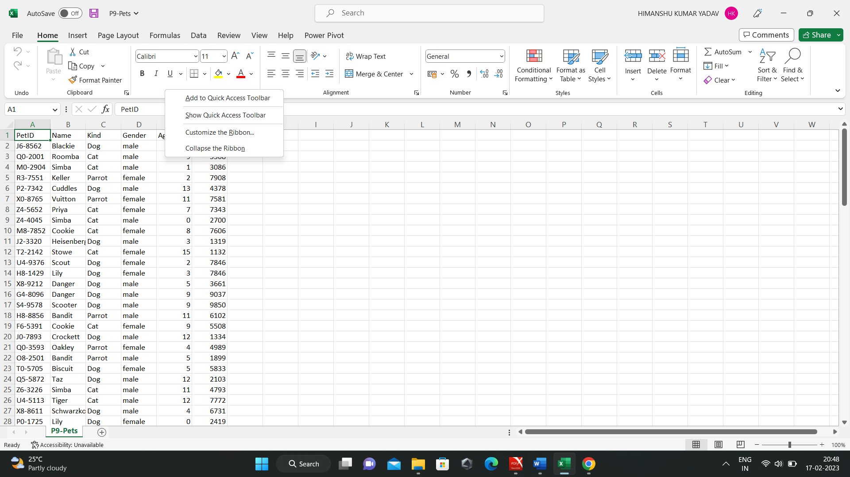

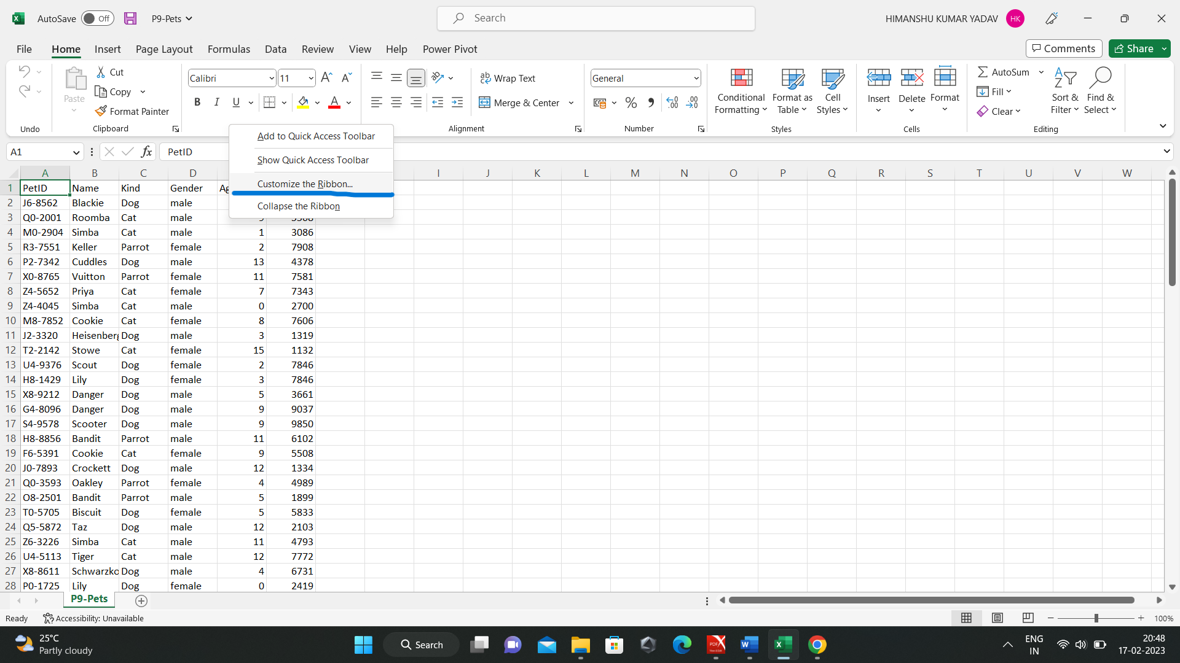

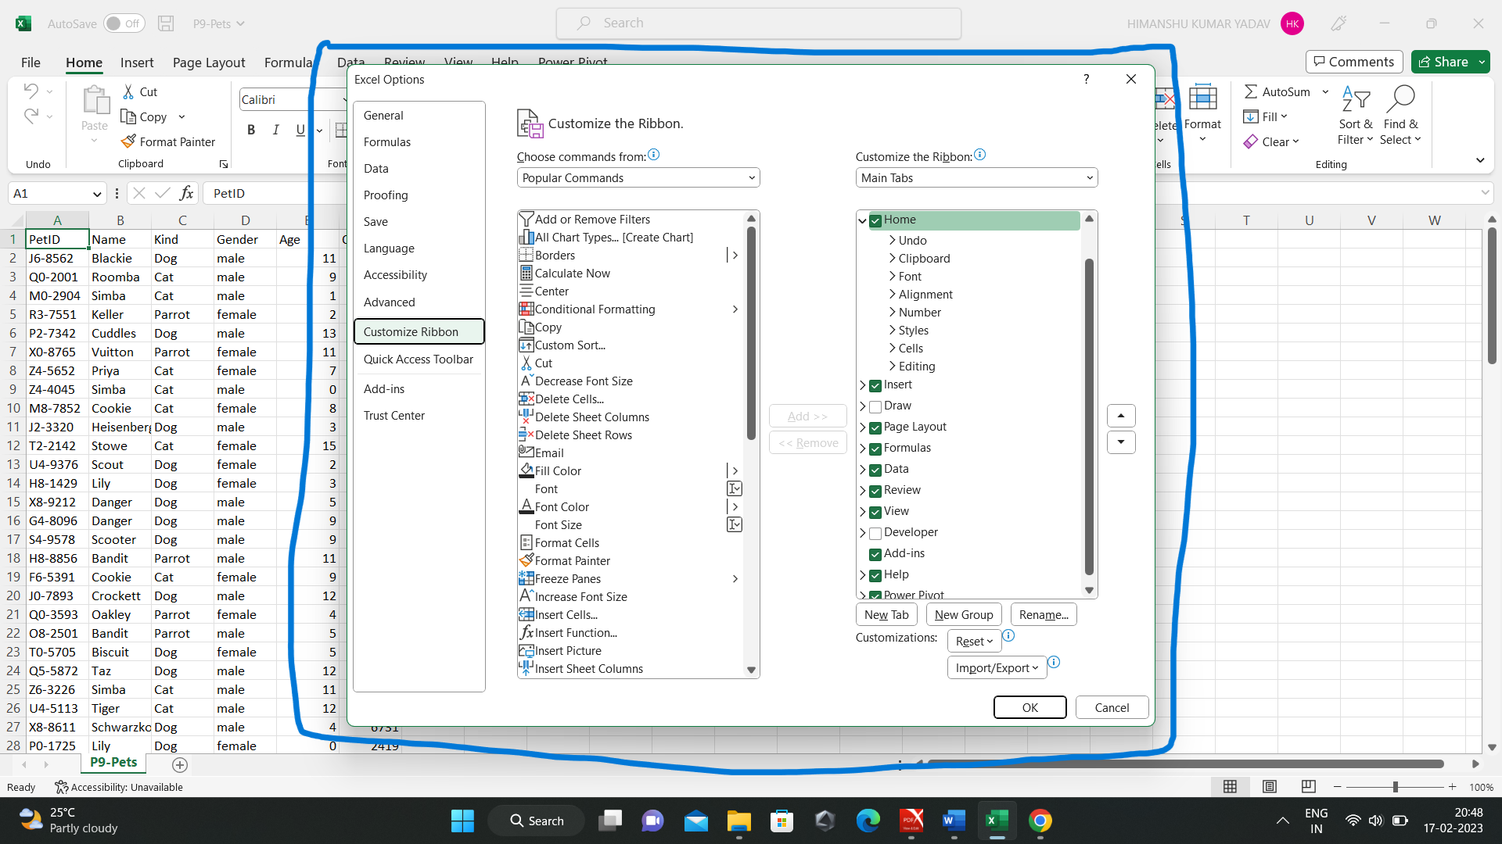

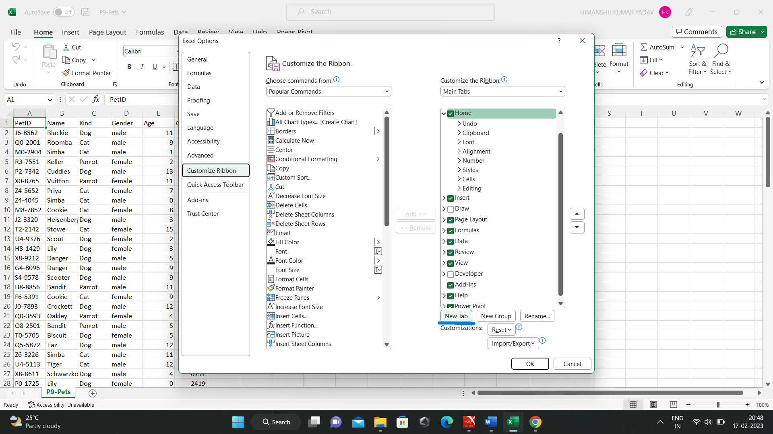

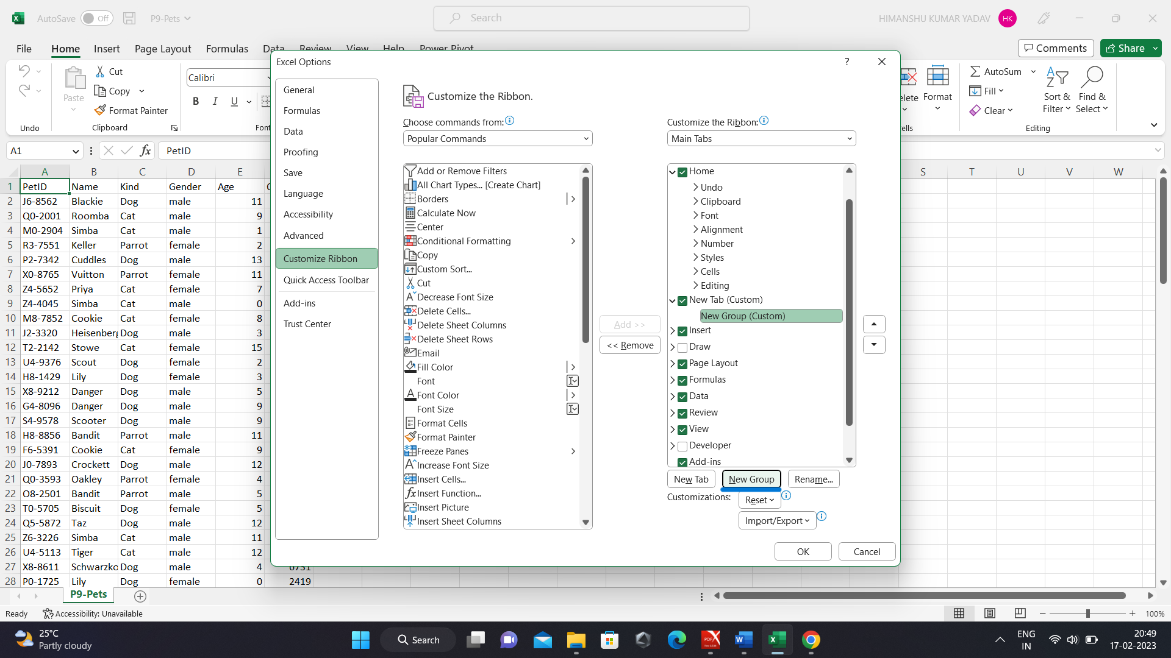

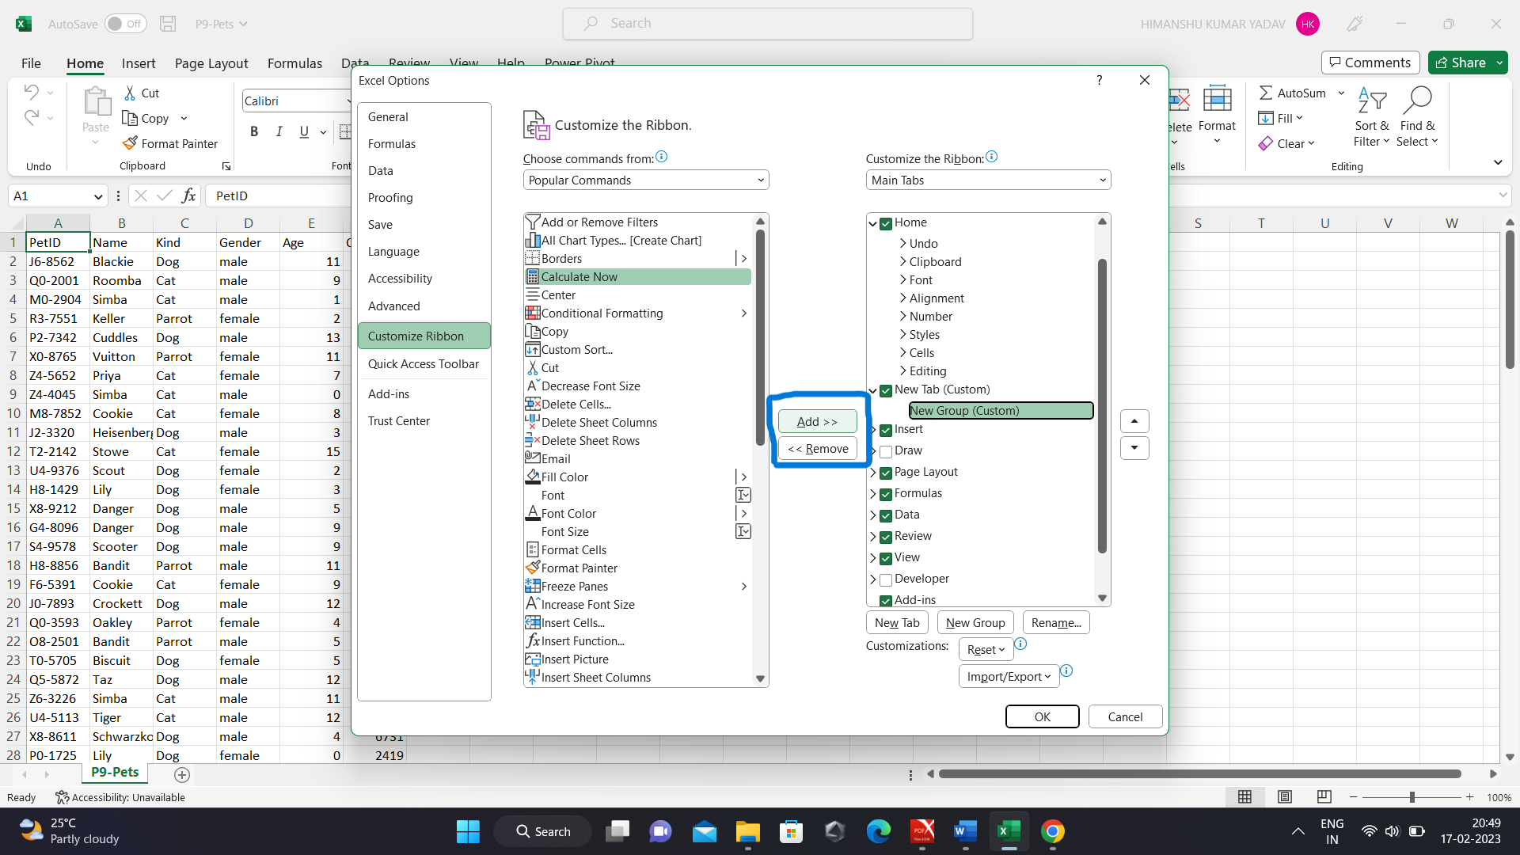

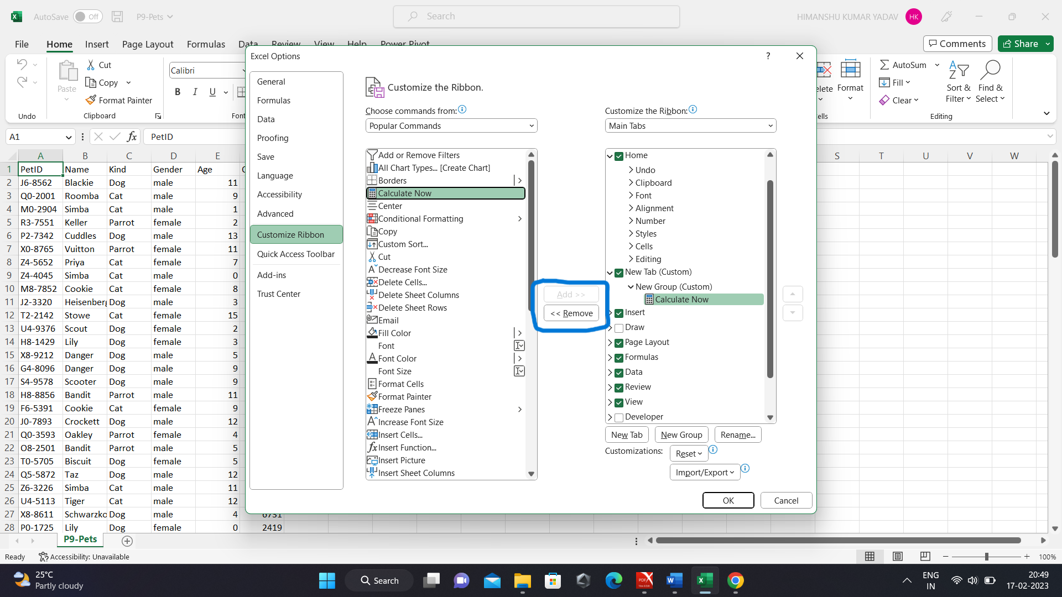

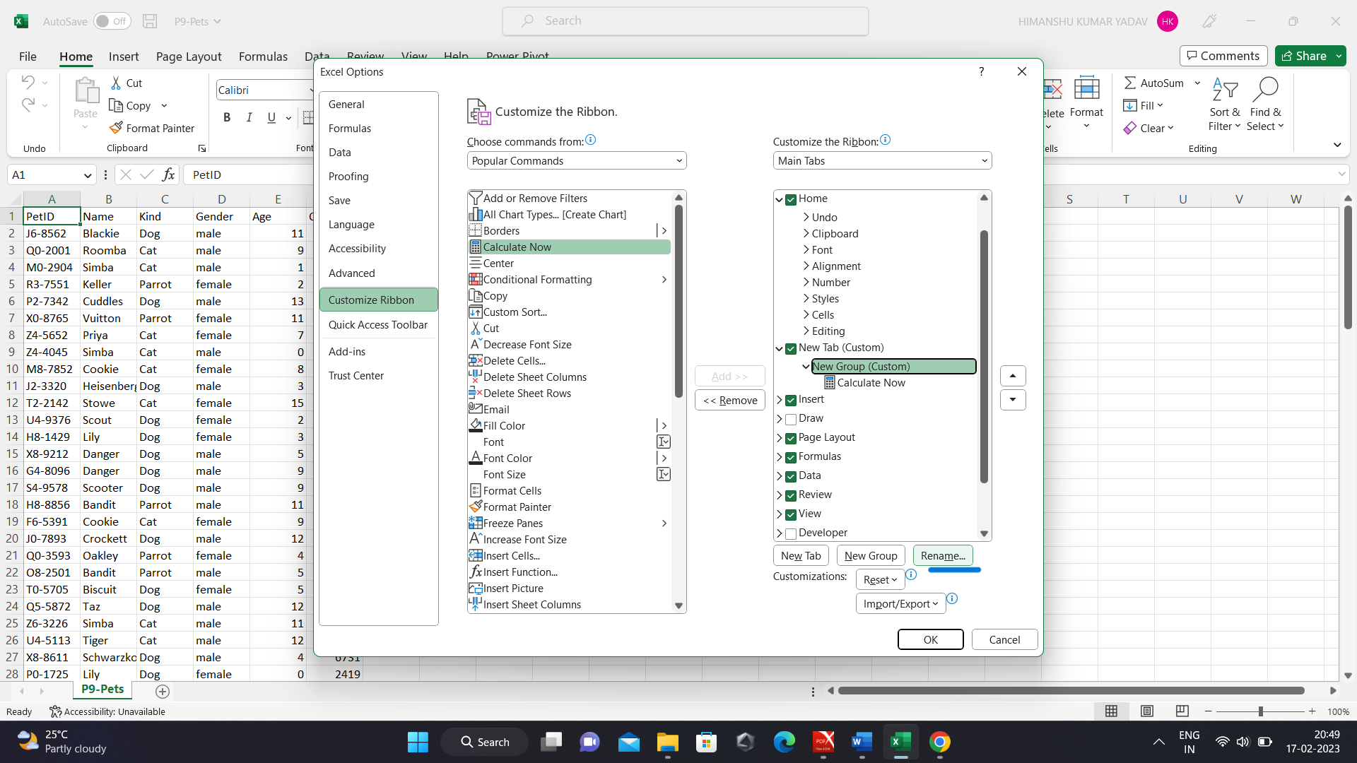

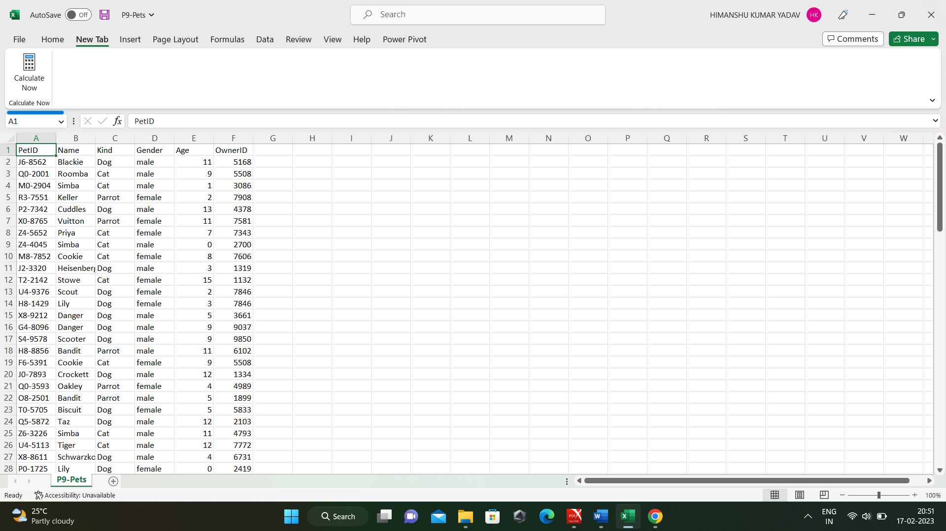

1. Here is a list of some commonly used shortcut keys for formatting in Excel:

* Ctrl + B: Bold - applies or removes bold formatting from the selected text.
* Ctrl + I: Italic - applies or removes italic formatting from the selected text.
* Ctrl + U: Underline - applies or removes underline formatting from the selected text.
* Ctrl + 1: Format Cells - opens the Format Cells dialog box, allowing you to apply various formatting options to the selected cells.
* Ctrl + Shift + #: Date format - applies the default date format to the selected cells.
* Ctrl + Shift + @: Time format - applies the default time format to the selected cells.
* Ctrl + Shift + $: Currency format - applies the default currency format to the selected cells.
* Ctrl + Shift + %: Percentage format - applies the default percentage format to the selected cells.
* Ctrl + Shift + &: Border - applies a thin border to the selected cells.
* Ctrl + Shift + _: Remove border - removes the border from the selected cells.

1. Excel is a powerful analytical tool that has some key features that distinguish it from other tools. Here are a few things that set Excel apart:

* Versatility: Excel is an extremely versatile tool that can be used for a wide range of tasks. It can be used for simple calculations, data analysis, financial modeling, and much more. This versatility makes it a useful tool for many different types of users, from casual users to financial analysts and data scientists.
* Ease of use: Excel has a relatively simple and intuitive interface that is easy to use. Many users are already familiar with Excel, and even those who are not can quickly learn the basics. This ease of use makes it accessible to a wide range of users.
* Built-in functions: Excel comes with a wide range of built-in functions that make it easy to perform complex calculations and data analysis. These functions include statistical functions, financial functions, text functions, and much more. Many of these functions can be used by entering simple formulas into cells, making it easy to create powerful analytical tools.
* Customization: Excel can be customized in many ways to suit the needs of individual users. Users can create custom formulas, macros, and add-ins to automate tasks and perform complex analysis. Additionally, users can customize the appearance of their spreadsheets by using custom styles and formatting options.
* Accessibility: Excel is widely available and can be used on a variety of devices, including desktop computers, laptops, and mobile devices. Additionally, Excel files can be easily shared and collaborated on, making it a useful tool for teams and organizations.

